Cash of Crash (SP mode)/ Max Crash (BTG mode)
Software Requirements Specification
Version: 1.1
Table of content
Glossary 3
Overview 4
SP Mode 4
BTG Mode 5
Gameplay 6
Placing Bets 6
Manual Bets 6
Auto Eject (the algorithm of work is presented and is at the stage of approval) 6
Auto Bets 7
Game Logic / Math 8
SP Mode 8
BTG Mode 11
UI / UX 14
SP Mode 14
Common representation 14
Playing field 15
Bets field 17
Auto Eject extension (Design and algorithm at the stage of confirmation) 18
Previous crash results 19
Toolbar 19
Detailed history of past rounds 20
Players table 20

Glossary
Casino Manager (CM) — BSG backoffice system, through which promotional campaigns (Mystery Drops) can be created and the necessary reports on ongoing and completed promotions are available.
Bank — online casino. That is, a conventional unit that combines a set of different configurations and has a set of games that players play on a specific site (or its mirrors).
BTG (Battleground) Mode — new mode will be a series of one-round games, continuing permanently. The most important thing to start each round is the presence of at least two players willing to play. Battleground mode will not be tied to a specific start and end date, so it can satisfy the need for players to compete with other players "here and now" and get a reward for it.

Crash games — type of casino games in which a bet is placed on the fact that the object will exist for some time before its crash. The closer the length of time for which the bet was to the time of the crash, the greater the winning multiplier.

Multiplier — value that regulates the player's payout if he wins. Starts to increase from 1x when the vehicle starts moving. If the player wins, the payout is equal to the bet multiplied by this multiplier.

Passenger — an object that the player controls (places a bet on it and chooses the moment of its eject). In this game - Astronaut.

Room — virtual game room containing 1 or more players (limited value) and set bet limits.

Round — period of time starting from the placing bets of all players and ending with some result formed by the game logic (win or loss for each rate).

SP Mode — game mode in which one or more players can play in a room. The game will start even if there is only one player in the room (i.e. a game against a computer).

Vehicle — the main object of the game, which starts movement at the beginning of the round and crashes at a certain moment (end of the round). During the movement of this
object, the multiplier increases according to the mathematical model. In this game - Rocket.

Overview

SP Mode
The main idea of ​​the game is that players place a bet from the available ones (in interval of bet limits) on the fact that the passenger they are driving will have time to leave the vehicle before it crashes. The round begins with the movement of the vehicle. As it moves, the multiplier grows (from 1x) according to the mathematical model. While the object is moving, the player can eject a passenger controlled by him by pressing a specific button. At some point, the rocket explodes (crash). All passengers of the players who did not eject before the explosion - lose (the bet on this passenger is considered lost). If the player managed to eject the passenger before the explosion, then he will receive a payout equal to the multiplier at the moment of eject multiplied by the bet. As a result, the maximum payout is received by the players who eject the passenger out of the rocket in the time closest to the explosion.
In this mode, the game is a casino game with the possibility of simultaneous play of several players through the game rooms. The minimum number of players is 1. The game is tied to the bank. The bank also has a limit on the betting limits. Each room can have up to 100 players at a time. Players in different currencies can exist in the same room. Each player can place from 1 to 3 bets (can drive 3 passengers in a vehicle) per round of the game. Rooms should not appear empty, balancing is needed when defining a player to a room.
The round is the time interval from the start of the vehicle movement until it crashes. Before the start of the round, the players are given n time to place their bets. The rounds are repeated continuously every n time (set by the configuration). The round ends when the object crashes.
The player can eject the passenger manually or by using an automatic eject (by specifying a multiplier to be achieved). Each player in the room has a random Nickname. All confirmed bets of players in the room and their payouts are displayed in a special window of the interface.
In the future, there may be a mode of automatic bets (for several rounds with a stop when certain parameters are reached).

BTG Mode
This mode has important differences from the SP mode:
- There are no bets. There is only an initial fee (buy-in) for entering the room (selected from the available ones).
- In this mode, the player controls only one passenger.
- In one room, all players have the same currency.
- In one room, all players have the same buy-in.
- The minimum number of players to start the game is 2.
- The maximum number of players in one room is 50.
- Before the start of the round, the player waits for a certain time for other players.
- Players compete against each other.
- The player who ejects the passenger from the rocket closest to the rocket explosion wins.
- The player receives a payment equal to the sum of the initial buy-in of all players, excluding the casino commission.
- Multiple players can win. In this case, the pot (sum of the initial buy-in) will be distributed among the winners in equal shares, with the exception of the casino commission.
- After the end of the round, the player can start over at the same buy-in, or change the buy-in.
- If all players have not ejected passengers out of the vehicle before the crash, then the buy-ins are returned to the players, with the exception of the casino commission.
The general algorithm of the game is as follows. The player selects BTG mode when entering the game. Next, the player chooses a buy-in from the available ones. Having chosen the desired buy-in, the player enters a room where there are already other players or not yet. Further, the game waits for the room to fill up for a certain period of time. If at the end of the time there are at least 2 players (lower limit) in the room, then the game starts. If there are 50 players (upper limit) before the timer expires, the game starts immediately. The game starts with the movement of the vehicle. The player who ejects his passenger as close as possible to the time of crash of the vehicle is the winner. The winner will receive a payout equal to the sum of player's buy-ins, excluding the casino commission. After that, players are invited to continue playing in this room at this buy-in or change it.

Gameplay

Placing Bets
The player can place bets in two ways - with manually eject or automatically eject (by multiplier) for each bet. During the auto eject mode for a bet, the player can manually eject the passenger up to the specified multiplier. All bets can be placed before the start of the round (special interval). If the player entered the room already during the gameplay, then he will be able to place bets only after the end of the current round.
Also, in the future, there may be an automatic betting mode and betting on the next round.

Manual Bets
In this mode, the player can place manually from 1 to 3 bets per round and decide for himself at what moment to eject the passenger out of the vehicle.
Each bet has one passenger in the vehicle. That is, if the player places 3 bets, then during the round he controls each of the 3 passengers. After the start of the round, the player can no longer place bets (the button is inactive). Each bet wagered by a player will be displayed in the player list.
The player can select the value of the bet from the list of available ones or enter the value of the bet in the field on his own (however, only in the available limits).
The player can also cancel the bet if there is more than 1 second left before the start of the round. In this case, the money will be returned to the player.
After the start of the round, the "Place" button is replaced by the “Eject” button. By pressing the “Eject” button, the player ejects his passenger out of the vehicle.

Auto Eject (the algorithm of work is presented and is at the stage of approval)
This mode is an extension of the manual betting mode and can be applied separately for each bet. However, in this case, the player must indicate a specific multiplier at which the passenger will be ejected out of the vehicle. The player can set an auto eject for any of 3 bets in manual mode. That is, the player can set 1 bet with a manual eject and 2 with an automatic, with any multiplier for each of the 2 bets. The player cannot specify a multiplier equal to 1x (only >1x, min 1.01x). Also, the player can manually eject the passenger from the rocket for which the auto eject is set, if this multiplier has not yet been reached.
Basically, this mode is necessary for players with poor Internet connection (high ping). Thus, using this mode, passengers are guaranteed to be ejected out of the vehicle as soon as it reaches the desired value.
If the vehicle has not reached the specified multiplier, then the bet will be lost.

Auto Bets
This mode is not implemented in the initial implementation, but it may exist in the future. The main idea of this mode is that bets will be placed automatically. The player can specify the number of rounds, the value of bets, the value of multipliers or payouts, as well as other parameters at which the passenger will be ejected out. Also, the player can specify some parameters to stop the automatic betting mode.

Game Logic / Math

SP Mode
In this mode, the mathematics of the game is quite simple. All players place bets on their vehicle passengers. At the start of the round, the server preselects the moment of the crash of the vehicle using a special formula. If the server chooses 1x multiplier, then the vehicle immediately crashes and everyone loses. If the multiplier calculated by the server is greater than 1x, then the vehicle starts moving. The time-dependent server function constantly updates the current multiplier and checks the status of each passenger in the vehicle. If the player ejects the passenger before the crash of the vehicle, then he receives the payment corresponding to the current multiplayer. The round ends with a vehicle crash.
If all players have not ejected passengers out of the vehicle before the crash, then all players lose.
This logic is shown in Picture 1.

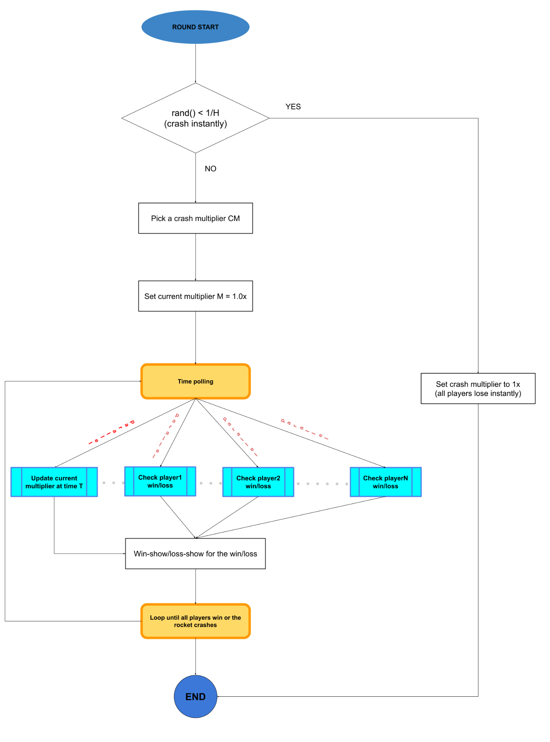
Picture 1 - Game logic diagram (SP Mode)

Crash multiplier function:

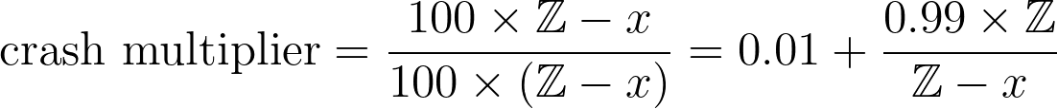

The Z parameter is $2^{52}$ . The x parameter is defined using RNG, like: Z $×$ RNG.rand().
According to these values, the theoretical RTP should be 96%.

BTG Mode
In this mode, there are differences in relation to the SP mode. Players do not place bets, but only make an initial fee - buy-in, upon entering the room. The game can start only if the room picks up at least 2 players within a certain period of time. If maximum possible (50) players enter the room, the game starts immediately. Each player has the same buy-in in one room. All players buy-ins form a pot. Next, the server calculates the moment of the vehicle crash using a special formula. The formula has been slightly modified relative to the SP mode to achieve a longer travel time for the vehicle. The time-dependent server function constantly updates the current multiplier and checks the status of each passenger in the vehicle.
Each player can eject his passenger at any time. The winner is the player with the maximum eject multiplier. At the end of the round (vehicle crash), the player whose eject multiplier is higher than the others receives a payout equal to the sum of all buy-ins, except for the casino commission. Also, it may happen that several players eject passengers at the moment with the same multiplier (that is, at the same time) and they become the winners (their multipliers are the largest). In this case, the pot is divided in equal parts into these players.
If all players have not ejected passengers out of the vehicle before the crash, then the buy-ins are returned to the players, with the exception of the casino commission.
This logic is shown in Picture 2.
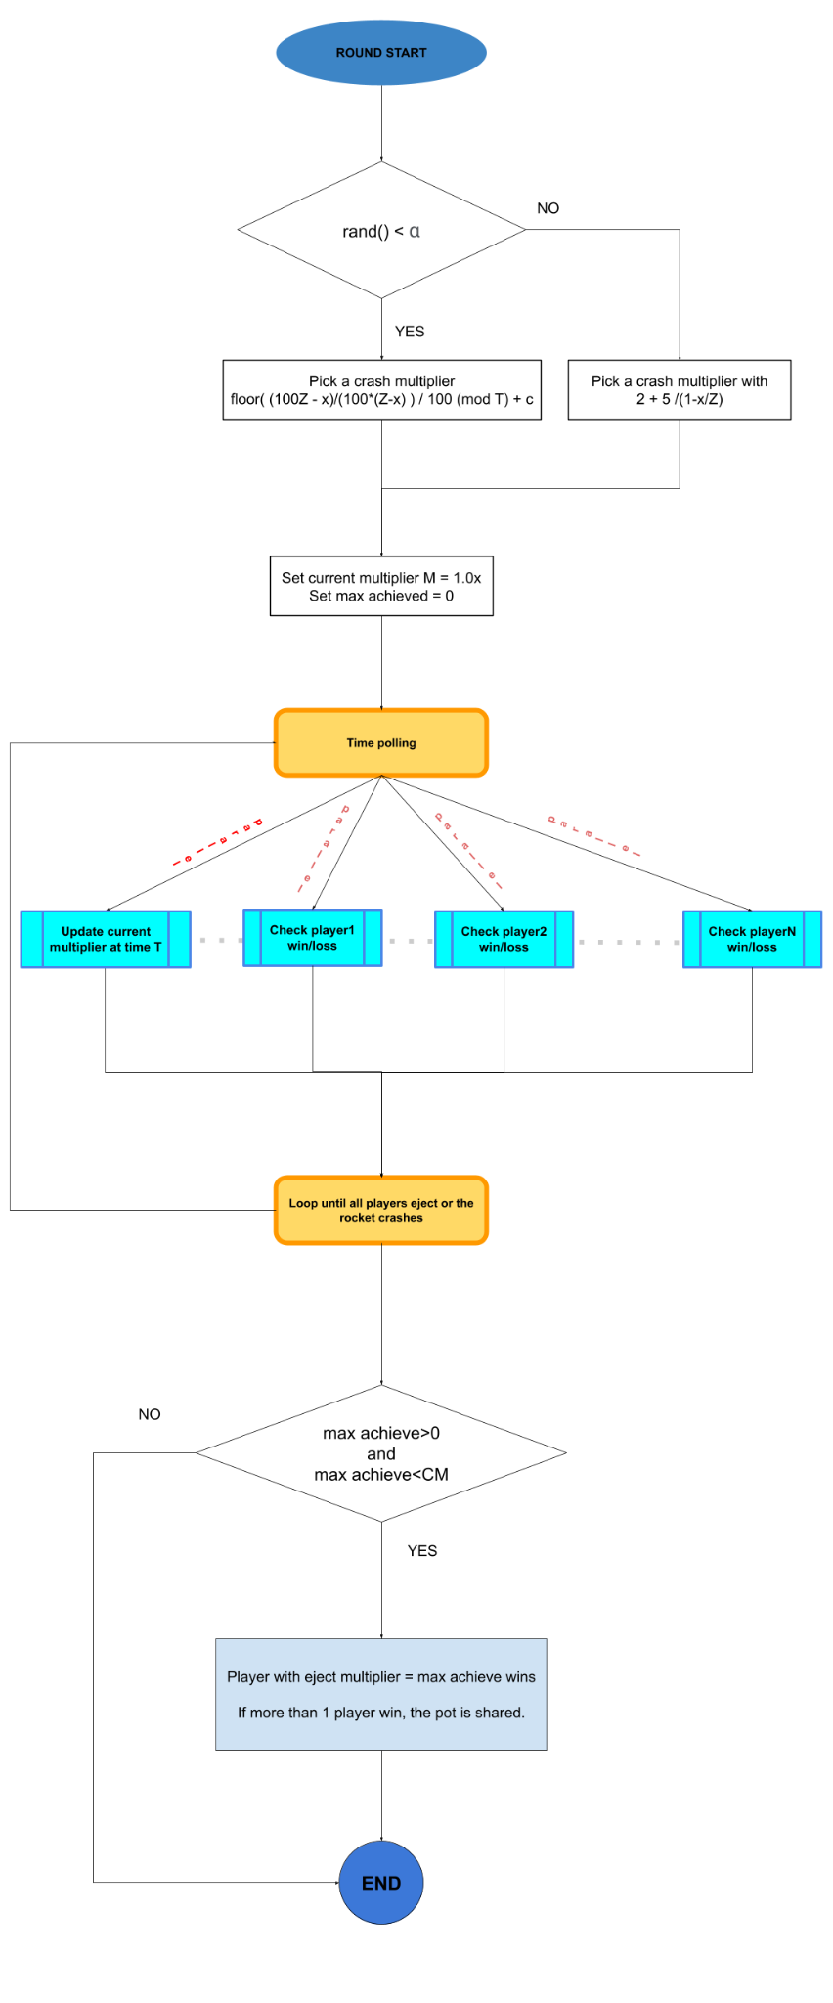
Picture 2 - Game logic diagram (BTG Mode)
Crash multiplier function:

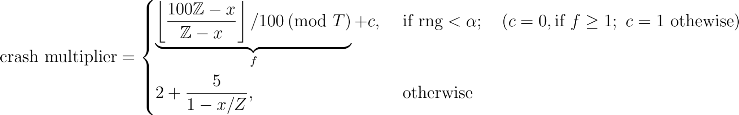

The Z parameter corresponds to the parameter from the mathematics for the SP mode. Parameter α is chosen to be 0.75 but subject to change if the player experience is not as good as expected.

UI / UX

SP Mode

Common representation
In this mode, after loading, the game looks like this:
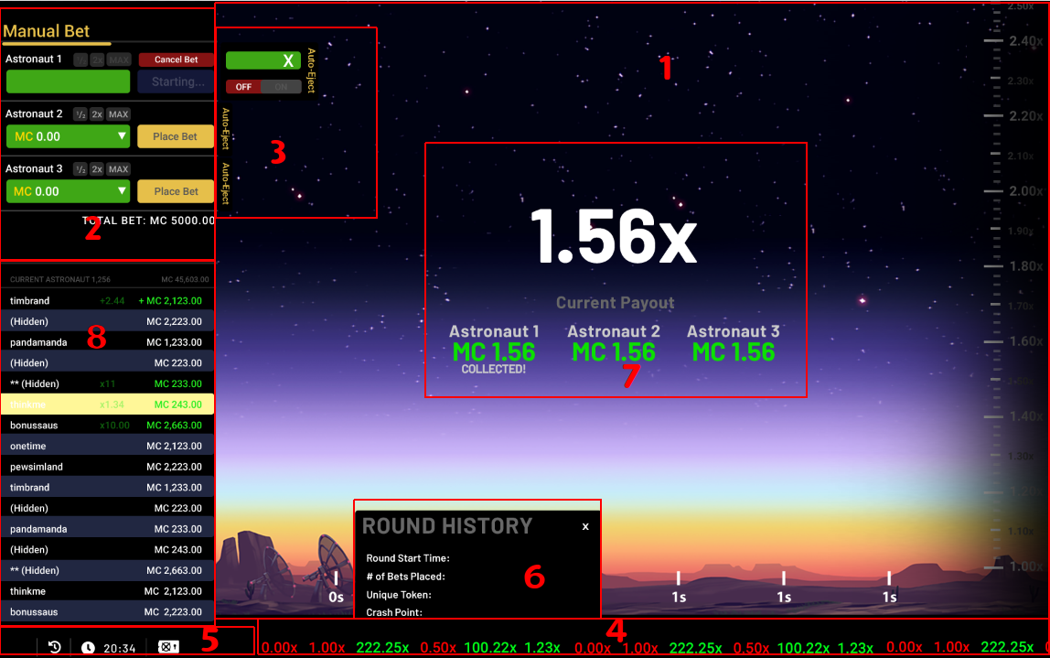
The game is represented by 4 main blocks:
- The main playing field. On this field, the player will see the countdown of the time until the start of the round, the movement of the vehicle, the line of the vehicle's trajectory, passengers ejects out of the vehicle and their wins. Also on this field you can see the multiplier corresponding to the position of the vehicle at a certain moment (vertical scale), as well as the duration of the vehicle's movement (horizontal scale).
- Manual Bet field.
- Auto Eject extension for the Manual Bet mode.
- Previous crash results. This line shows the values of the multipliers at which the vehicle crashed in the previous rounds of this room.
- Toolbar. Necessary buttons for customizing the game client, as well as a balance indicator.
- A detailed history of past rounds in this room.
- The indicator of the current multiplier during the movement of the vehicle's, as well as all current payments for each of the player's bets.
- Players table. This table shows the nicknames of the players, the bets made by a particular player, the multipliers on which the player ejected his passenger, the value of winning or losing.

Playing field
This is the main field that shows the progress of the round and its outcome. During the time interval before the start of the round, a countdown is shown on this field - picture 3.

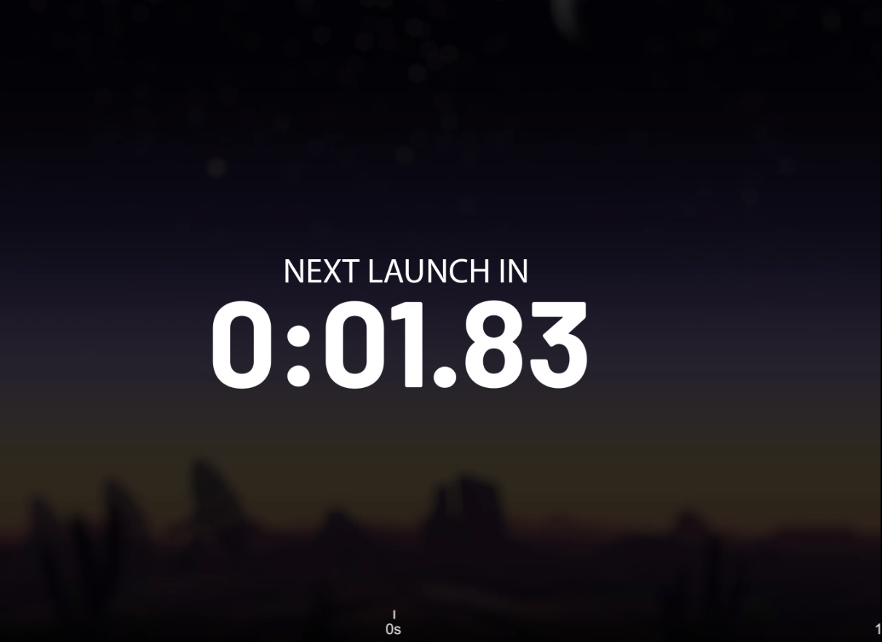
Picture 3 - Countdown before start
After the start of the round, the vehicle (in this case, the rocket) begins to move across this field. Also, while driving, the trajectory of the vehicle is drawn. The vertical scale shows the multiplier at which the vehicle is currently located. The horizontal scale shows the number of seconds on the way. The center of the field also displays the current multiplier and the absolute value of the payout at the moment (it grows while moving) for each bet. If the player has placed more than 1 bet, then all payments at the current moment will also be displayed in this field. If the player has ejected out the passenger and won, then below the payout there will be an inscription "Collected" (7’th view of common representation). Picture 4.
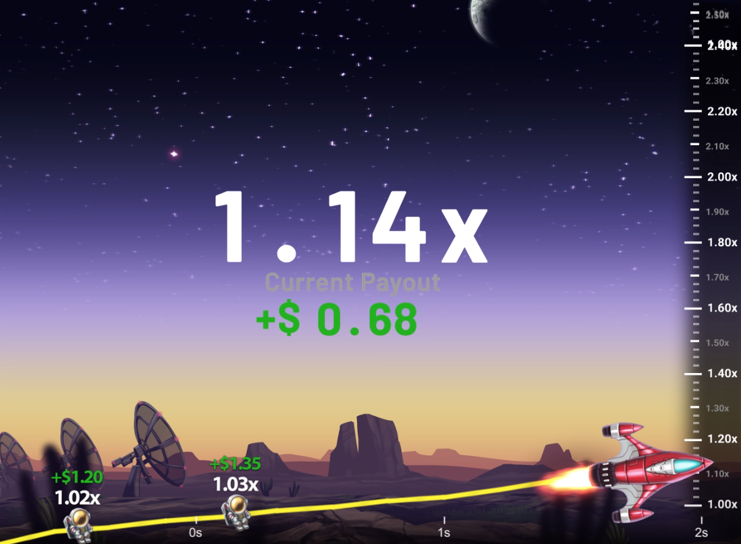
Picture 4 - Main game action for 1 bet
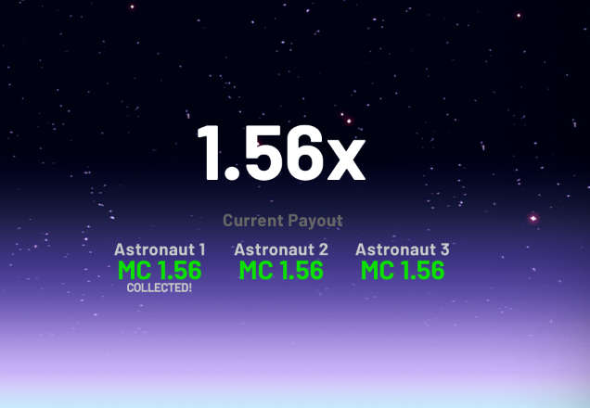
Picture 5 - Main game action for 3 bets
When a player ejects his passenger, he is also displayed on this field, as well as his multiplier and the absolute value of the payout (near the passenger). Picture 6.

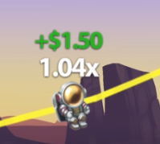
Picture 6 - Ejected passenger

Bets field
In this field, the player has 3 fields for entering a bet. One passenger corresponds to each field of the bet. The bets may be different for each passenger. The player himself enters the value of the bet in the available interval (limits of room) or selects from a list of some prepared values. Values ​​can only be integers. If a player has entered a bet value that is outside the limits, then the "Place Bet" button will be blocked, and a red inscription informing about the limits will appear below the bet field.
After entering the value (and before the start of the round), the player presses the "Place Bet" button and confirms the bet (the button becomes inactive). Also, before the start of the round, the "Cancel" button becomes active. The player can cancel a confirmed bet at least one second before the start of the round. Also, each field contains the designation of the currency.
Each bet has buttons:
- "1/2" - divides the current bet in half. If the value is less than the available lower limit, then the minimum value of the limit is set.
- "2x" - Increases the current bet by 2x. If the value is greater than the available upper limit, then the maximum value of the limit is set.
- "MAX" - sets the maximum bet value available for this room.
These buttons are available for bets that have not yet been confirmed (the "Place Bet" button is active). After the start of the round, the "Place Bet" button is replaced with a "Eject" button. Pressing this button ejects the passenger from the vehicle.
After the end of the round, the "Place Bet" button is again available. The total bet is displayed at the bottom of this field.

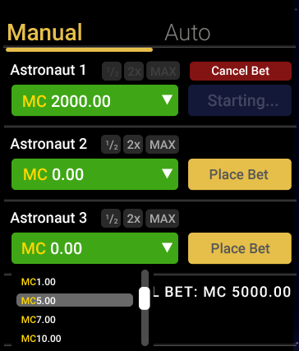
Picture 7 - Manual bets field

Auto Eject extension (Design and algorithm at the stage of confirmation)
This extension is a slide-out menu for each bet. The player also has 3 fields for entering the bet value (manual mode fields). However, for each field there are 1 more field for choosing a multiplier in the expanded menu. In the menu the player can choose for which bet to use Auto Eject (ON/OFF buttons). Also, the player can enter the desired multiplier (not less than 1.01x). If the player has not turned on Auto Eject, then infinity is displayed in the multiplier value. If the player has enabled Auto Eject, then the multiplier value is set by default to 1.01x. All views of this extension are shown in Picture 8.
The “Place Bet” button is also used to confirm each bet. Also, the player can manually eject the passenger from the rocket for which the auto eject is set, if this multiplier has not yet been reached.
As in the manual mode, there is a button to cancel the bet.
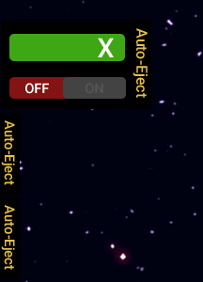
Picture 8 - Auto Eject views

Previous crash results
This field shows the multipliers by which the vehicle crashed in previous rounds of this room. If the multiplier was less than 2x, then the record is highlighted in red, if more, then in green.

Picture 9 - Rounds history

Toolbar
Picture 10 - Toolbar
This field is functional and informational at the same time.
Using the buttons in this field, you can:
1. Exit the game to the main Home page.
2. Open the history of your rounds (VBA).
3. Open the rules of the game.
4. Open detailed settings (at the moment the exact functionality is unknown)
5. Turn off the sound of the game.
Also, with the help of this toolbar, the player can see the time and his balance at the current moment.

Detailed history of past rounds
Popup that appears when clicking on a multiplier from the "previous crash results" view. In this window the players can see:
- Round start time.
- The number of bets in a round.
- Unique token (to be clarified).
- The multiplier at which the vehicle crashed.

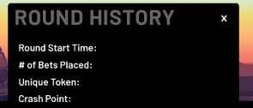
Picture 11 - Detailed round history

Players table
This field displays the player's nickname for each confirmed bet, currency code, bet value (highlighted in white).
If during the round the player wins, then the value of the bet is replaced by the value of the win (highlighted in green), and the multiplier on which this bet won is indicated in the line of the given bet (also highlighted in green).
After the round, losing bets are marked in red.
Each time the table is sorted in descending order of absolute monetary values. That is, as soon as the round begins and all bets are accepted, the table is sorted by the values ​​of these bets. As soon as some change occurs (for example, a player's win), the table is re-sorted taking into account this win (for example, this player rises in the table above).
If a player places 3 bets, then 3 entries with the same nickname appear in the table.
The rows of the table containing the player's bets are highlighted for him.
The final number of passengers and the sum of all bets are displayed at the top of the table.

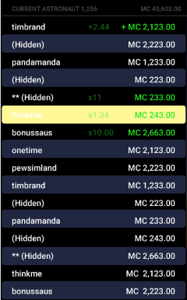
Picture 12 - Player’s table

BTG Mode (Section in the process of writing, awaiting assets)
At the moment, there is no description of this section, since the assets for the BTG mode have not been received.

